

Muntinlupa Baptish Church

Reports Tracking System

User Manual v1.0

MBC – RTS

Muntinlupa Baptis Church

Team Members:

Acuña, Julian SG.

Sagun, Paolo M.

Sia, Angelo G.

IT111

**Table of Contents**

1. Introduction……………………………………………………….……………1
2. User Groups…………………………………………………….………………1
3. Functionalities…………………………………………….……………….1
4. Registration and Login………………………………….…………………….1
5. *Registration………………………………………………………..……………………….1*
6. *Login…………………………………………………………………..……………………….4*
7. Backend…………………………………………………..………………………….5
   1. Event………………………………………………….….……………………………….5
8. *Create Events ……………………………………………………………………5*
9. *Event Viewing……………………………………………………………………6*
10. *Edit Events…………………………………………………………………………7*
11. *Delete Events…………………………………………………………………….8*
    1. Prayer…………………………………………………………………………………….9
12. *Create Prayer…………………………………………………………………….9*
13. *View Prayer………….………………………………………………………….10*
14. *Edit Prayer………….……………………………………………………………10*
15. *Delete Prayer…………………………………………………………………..11*
    1. Tithes……………………………………………………………………………………12
16. *Create Tithe……………………………………………………………………..12*
17. *View Tithe………………………………………………………………………..13*
18. *Edit Tithe…………….……………………………………………………………14*
19. *Delete Tithe…….……………………………………………………………….15*
20. Frontend…………………………………………………………………………..16
    1. Event………………………………………………………………………………..…16
21. *Event Viewing………………………………………………………………….16*
    1. Prayer…………………………………………………………………………………..16

*i. Create Prayer…………………………………………………………………..16*

*ii. View Prayer……………………………………………………………………..17*

*iii. Edit Prayer……………………………………………………………………….18*

*iv. Delete Prayer…………………………………………………………………..18*

**Introduction:**

The Muntinlupa Baptist Church Reports Tracking System is an online site that helps the organization deal with processes and activities that concerns them in a more organized and efficient way.

**User Groups:**

The client is the one who will be using the System. The stakeholders would be the following:

* Administrator – He/She will be the one responsible in managing the System.
* Members – They are the viewers and also have the capability to submit a prayer request.

**Registration and Login**

*Registration:*

* 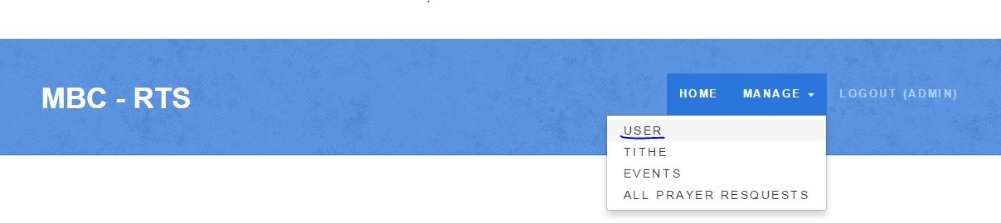Step 1: Using the Admin account, click the “manage” menu from the navigation bar and a dropdown list will appear. Click the “user” menu.

Figure 1.0 MBC Navigation Bar (User)

* Step 2: The Admin will be redirected to the “User” page. Click “Create User” to start creating an account.

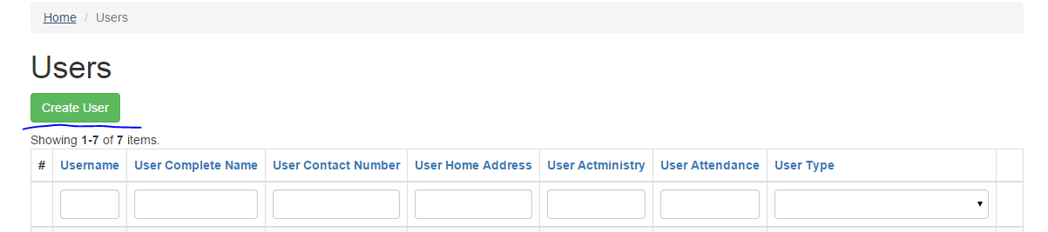

Figure 1.1 MBC Users Page

* Step 3: After clicking the “Create User” button. A new page will appear, and then you can start filling-up the fields to create an account. When all the fields are complete, you can now click “Add User” and you will be redirected to “User” Page and see the created user.

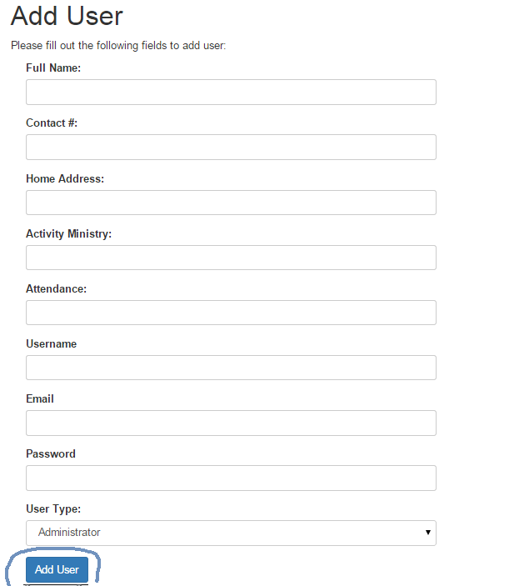

Figure 1.3 MBC “Add User” Page

*Login:*

* Step 1: The user must click the Login button from the navigation bar.

Figure 1.4 MBC Navigation Bar (Login)

* 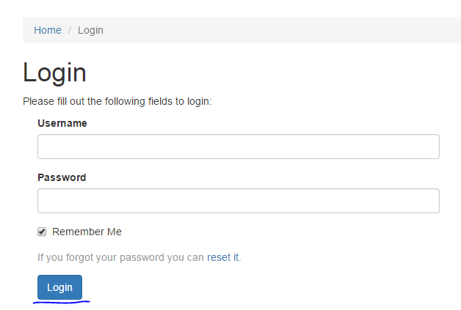Step 2: The user will be redirected to the Login page. The user will be asked to fill out the required fields before logging in. After filling out all the fields, click “Login”.

Figure 1.5 MBC Login Page

**Backend**

*Events* *(Create Events)*

* Step 1: Using the admin account, click “manage” from the navigation bar then click “events” after a list has been shown.

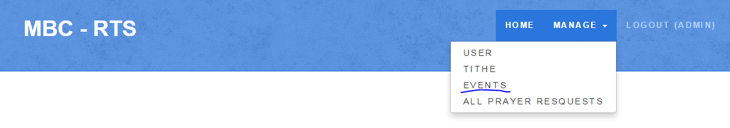

Figure 1.5 MBC Navigation Bar (Events)

* Step 2: Click “Create Events” to go to the Events Creation Page.

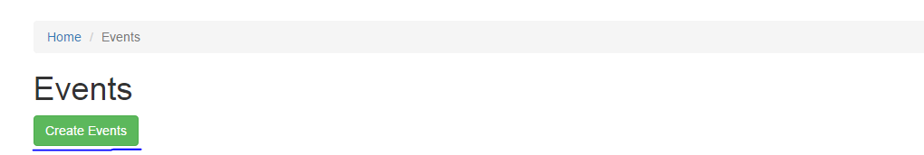

s

Figure 1.6 MBC Events Page

* 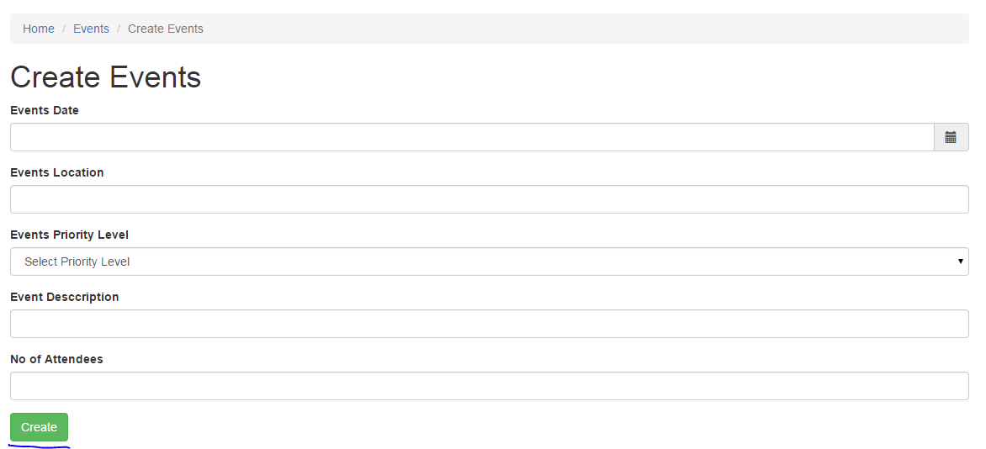Step 3: Fill out all the necessary fields for the Creating of the Event. Click “Create” after all the fields are complete.

Figure 1.7 MBC “Create Events” Page

*Events* (View Events)

* Step 1: Click the “Manage” menu from the navigation screen then click Events to see all the created events. (Refer to Figure 1.5)
* 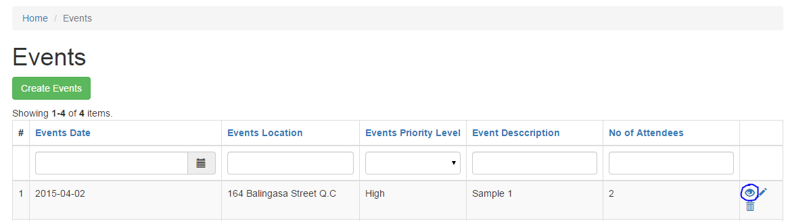Step 2: From the list of all events you can click the eye symbol to view a specific event.

Figure 1.8 MBC “Events” Page (Viewing)

*Events* *(Edit Events)*

* Step 1: After creating an event, the user will be redirected to a new page where he/she can view the event’s details. The user can edit the Event by clicking the “Update” button.

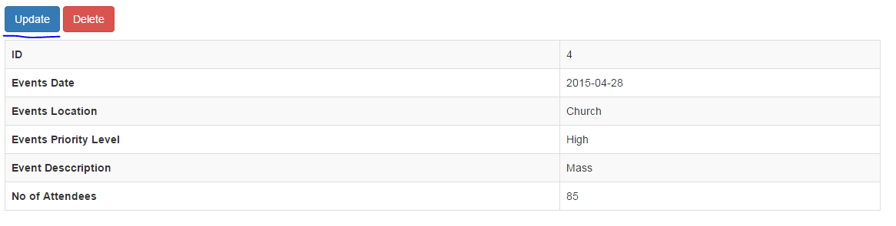Figure 1.9 MBC Update Page (Events)

* 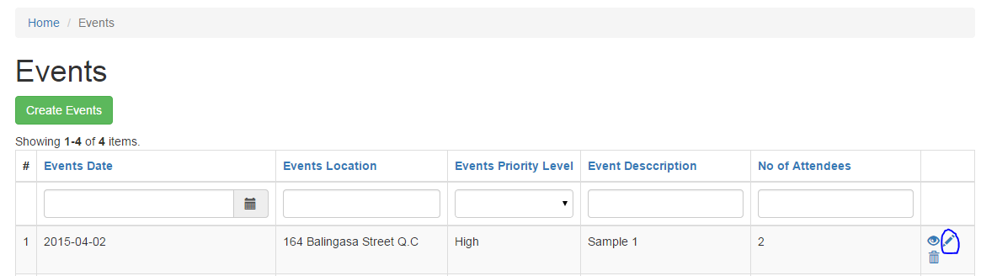Step 2: The user can also edit a specific event on the “Events” Page by clicking the pencil symbol.

Figure 2.0 MBC Events Page (Update)

*Events* *(Delete Events)*

* 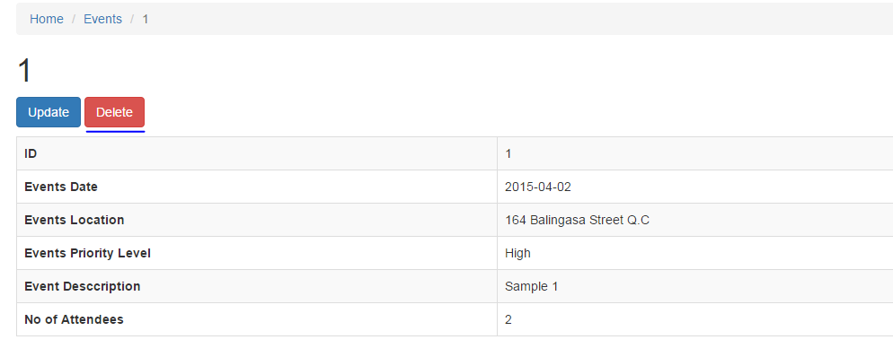Step 1: After creating an event, the user will be redirected to a new page where he/she can view the event’s details. The user can delete the Event by clicking the “Delete” button.

Figure 2.1 MBC Delete Page (Events)

* 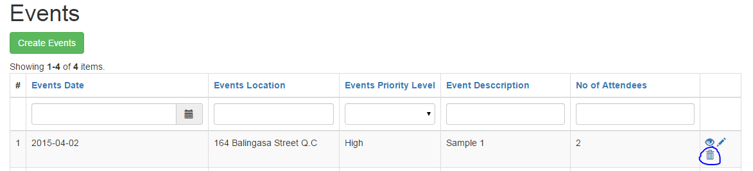Step 2: The user can also delete a specific event on the “Events” Page by clicking the trash bin symbol.

Figure 2.2 MBC Events Page (Delete)

*Prayers (Create Prayer)*

* Step 1: Using the admin account, click “manage” from the navigation bar then click “all prayer requests”.

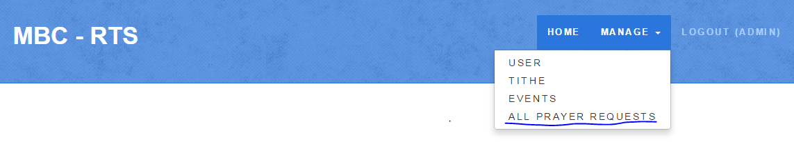Figure 2.3 MBC Navigation Bar (Prayers)

* Step 2: Click “Create” to proceed to Prayer Creation Page.

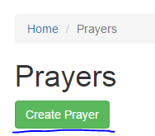

Figure 2.4 MBC Create Prayer

Figure 2.4 MBC Prayer Page

* Step 3: Fill out all the fields then click “Create”.

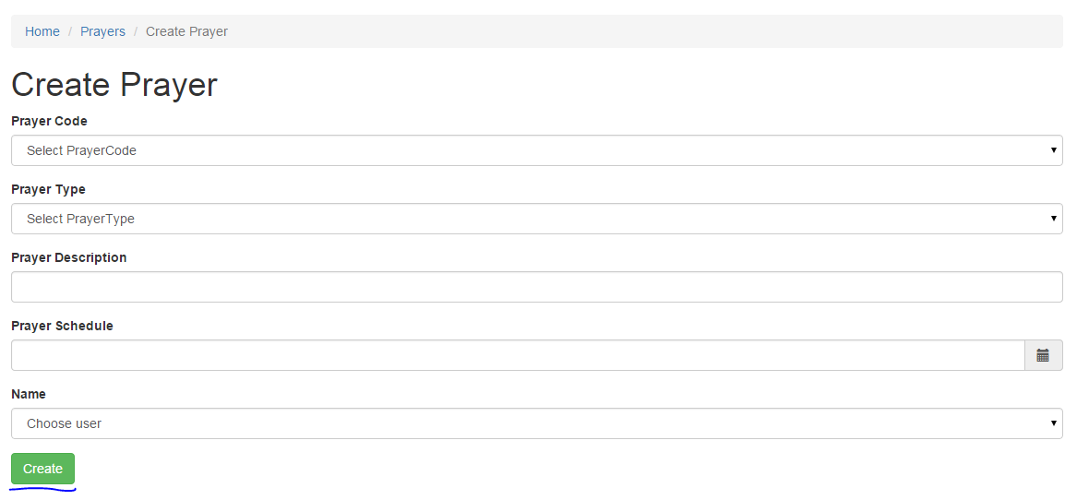

Figure 2.5 MBC Prayer Creation Page

*Prayers (View Prayer)*

* Step 1: Click the “Manage” menu from the navigation screen then click All Prayer Requests to see all the created prayers. (Refer to Figure 2.3)
* 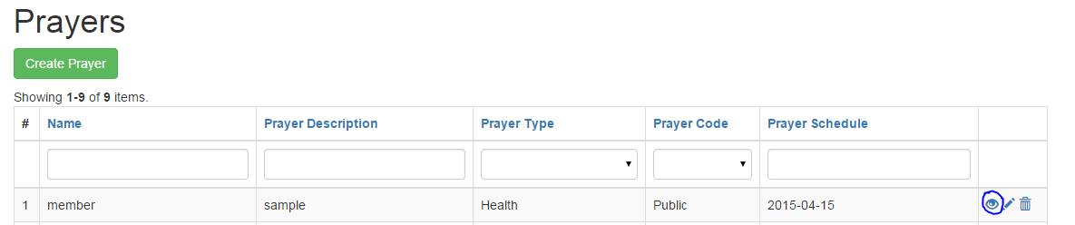Step 2: From the list of all prayers you can click the eye symbol to view a specific prayer request.

Figure 2.6 MBC Prayer Page (Viewing)

*Prayers (Edit Prayer)*

* 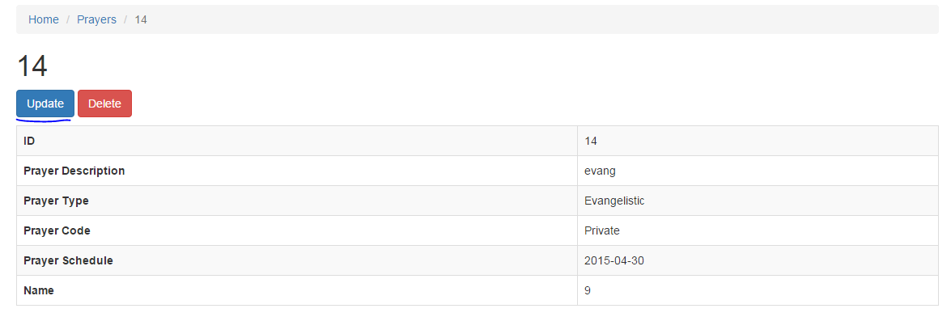Step 1: After creating a prayer request, the user will be redirected to a new page where he/she can view the prayer’s details. The user can edit the submitted prayer by clicking the “Update” button.

Figure 2.7 MBC Edit Page (Prayer)

* 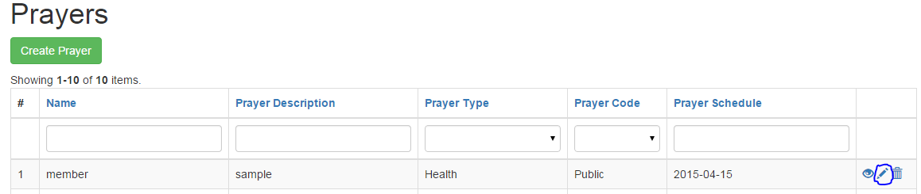Step 2: From the list of all prayers you can click the pencil symbol to edit a specific prayer request.

Figure 2.8 MBC Prayer Page (Update)

*Prayers (Delete Prayer)*

* 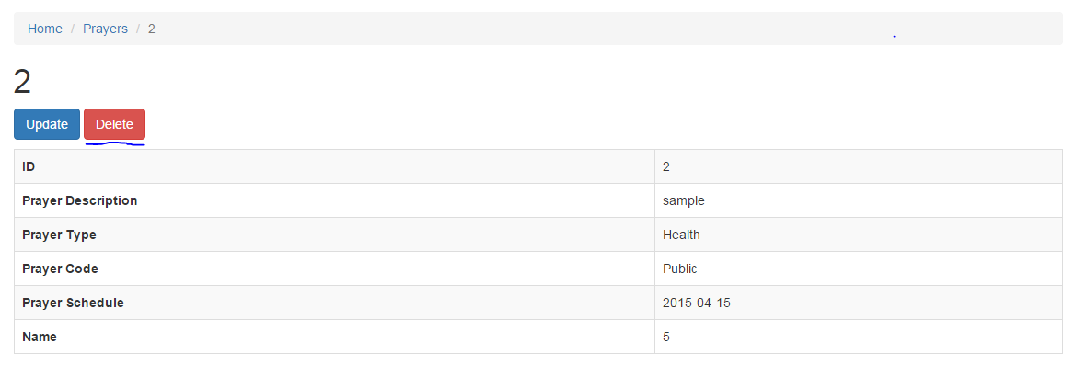Step 1: After creating a prayer request, the user will be redirected to a new page where he/she can delete the prayer request. The user can delete the submitted prayer by clicking the “Delete” button.

Figure 2.9 MBC Delete Page (Prayer)

* 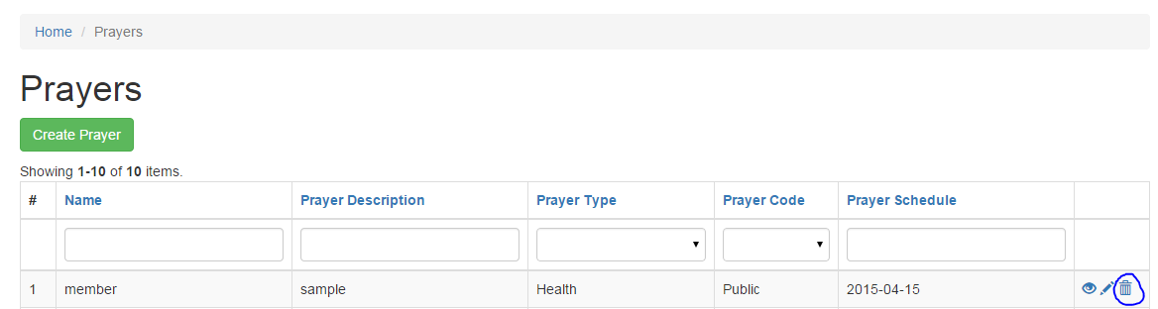Step 2: From the list of all prayers you can click the trash bin symbol to delete a specific prayer request.

Figure 3.0 MBC Prayer Page (Delete)

*Tithes (Create Tithes)*

* Step 1: From the navigation bar, click the “manage” menu then click Tithes.

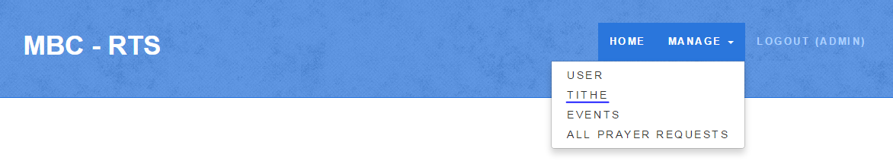

Figure 3.1 Navigation Bar (Tithe)

* Step 2: Click “Create Tithe” to proceed to Tithe Creation Page.

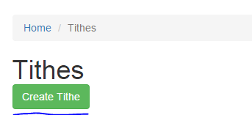

Figure 3.2 MBC Tithe Page

* 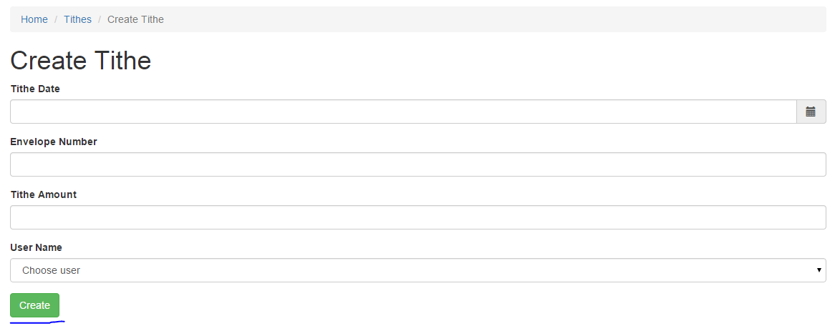Step 3: Fill out all the required fields then click “Create”.

Figure 3.3 MBC Tithe Creation Page

*Tithes (View Tithe)*

* Step 1: Click the “Manage” menu from the navigation screen then click Tithes to see all the created tithes. (Refer to Figure 3.1)
* Step 2: From the list of all tithes you can click the eye symbol to view a specific tithe.

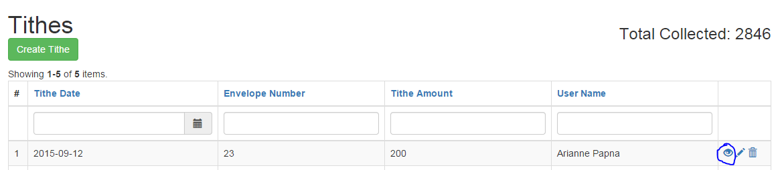Figure 3.4 MBC Tithe Page (Viewing)

*Tithes (Edit Tithes)*

* 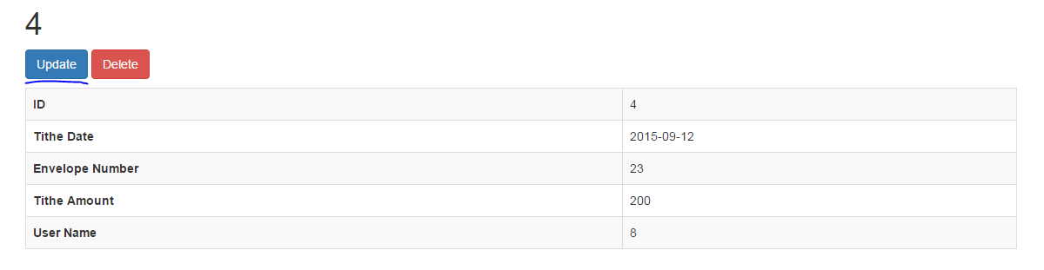Step 1: After creating a Tithe, the user will be redirected to a new page where he/she can view the Tithe’s details. The user can edit the submitted Tithe by clicking the “Update” button.

Figure 3.5 MBC Edit Page (Tithe)

* Step 2: From the list of all tithes you can click the pencil symbol to edit a specific tithe.

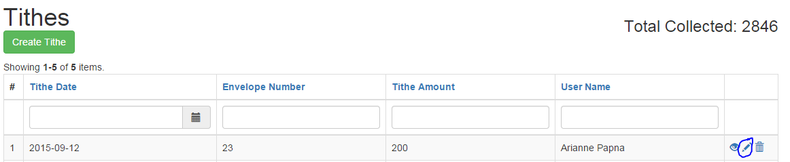

Figure 3.6 MBC Tithe Page (Edit)

*Tithes (Delete Tithes)*

* Step 1: After creating a Tithe, the user will be redirected to a new page where he/she can delete the Tithe’s details. The user can delete the submitted Tithe by clicking the “Delete” button.

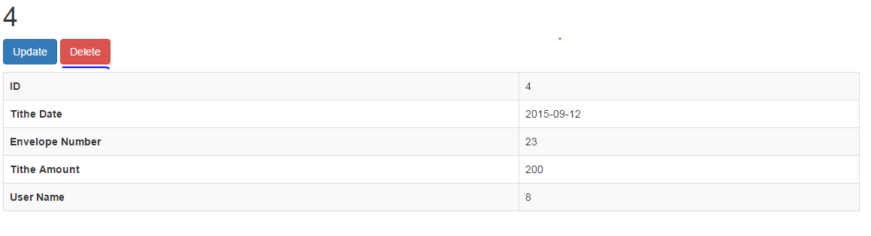

Figure 3.7 MBC Tithe Page (Delete)

* Step 2: From the list of all tithes you can click the pencil symbol to edit a specific tithe.

Figure 3.8 Tithe Deletion Page (Delete) 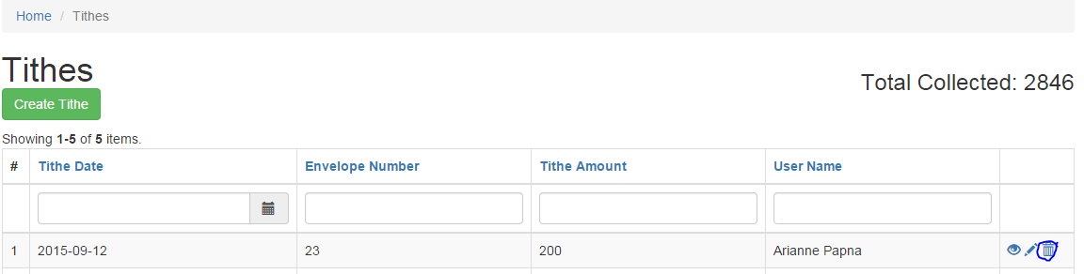

**Frontend**

*Event (Viewing*)

* 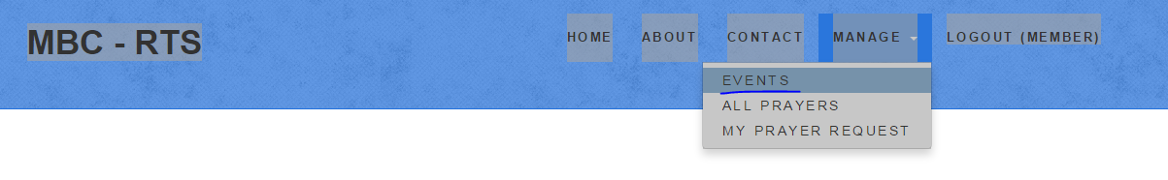Step 1: From the Navigation Bar, click the “manage” menu then click events.

Figure 3.9 MBC Navigation Bar (Member’s Events)

*Prayer (Create Prayer*)

* 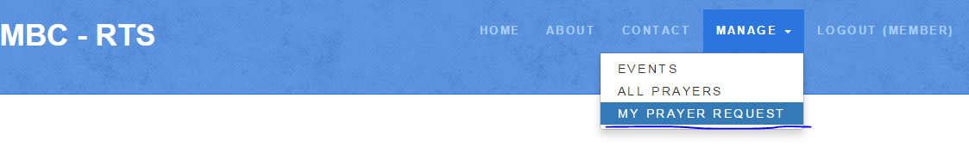Step 1: From the Navigation Bar, click the “manage” menu then click My Prayer Request.

Figure 4.0 MBC Navigation Bar (Member’s Prayer Request)

* Step 2: Click the “Create” button to proceed to start Requesting a Prayer

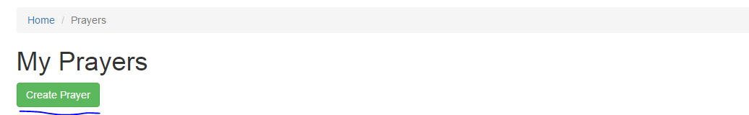Figure 4.1 MBC My Prayer’s Page (Create)

* 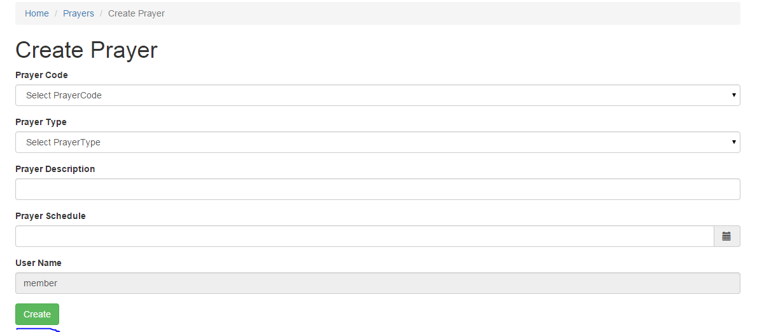Step 3: Fill out all the necessary fields then click “Create”.

Figure 4.2 MBC Creation of My Prayer Page

*Prayer (View Prayer*)

* 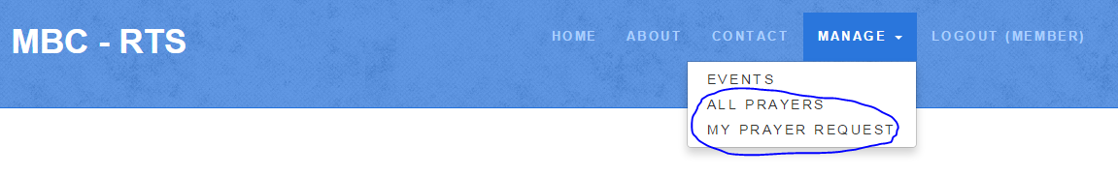Step 1: From the navigation bar, click “menu” then choose “all prayers” to view all the submitted prayers from other users. Choose “my prayer request” if you want to see your own prayers only.

Figure 4.3 MBC Navigation Bar (Member’s Prayer Viewing)

*Prayer (Edit Prayer*)

* Step 1: From the Navigation Bar, click “menu” then click my prayer request. (Refer to figure 4.0)
* 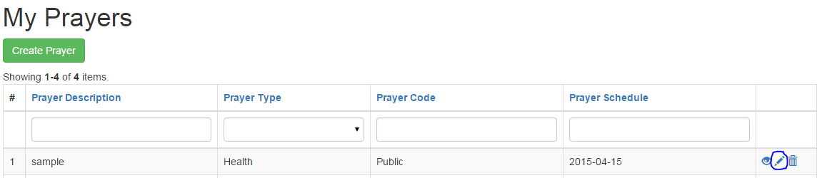Step 2: Click the pencil symbol to start updating a specific prayer request(Note: The User can only update his own prayer)

Figure 4.4 MBC Prayer Page (Update)

*Prayer (Delete Prayer*)

* Step 1: From the Navigation Bar, click “menu” then click my prayer request. (Refer to figure 4.0)
* 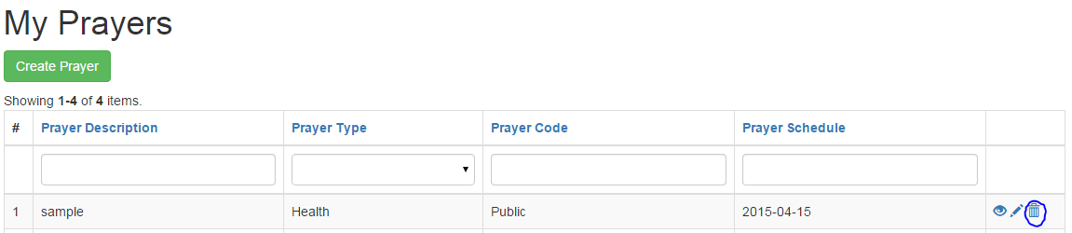Step 2. Click the trash bin symbol to start deleting a specific prayer request(Note: The User can only delete his own prayer)

Figure 4.5 MBC Prayer Page (Delete)